**ShopNest Store Power BI Capstone – Project Report**

Submitted to: Skillovilla

Date: 15th Dec 2024

Submitted by: Bijay Kumar Maity

**Contents**

**Introduction** 3

**1) Top Categories by Total Price** 3

**2) Delayed Orders Analysis** 4

**3) Monthly Comparison of Delayed and On-Time Orders** 5

**4) Payment Method Analysis** 6

**5) Product Rating Analysis** 7

**6) State-wise Sales Analysis** 8

**7) Seasonal Sales Patterns** 9

**8)  Revenue Analysis** 10

**Conclusion** 10

# **Introduction**

ShopNest is a leading e-commerce platform in Portugal, connecting local small businesses with a broader customer base. It enables merchants to showcase their products while facilitating direct shipments through logistics partners, streamlining the sales process.

This capstone project uses anonymized commercial data from ShopNest to uncover insights that can optimize operations and drive growth. The analysis covers key areas like sales trends, customer behavior, payment methods, order delays, and regional patterns, using Power BI for data visualization.

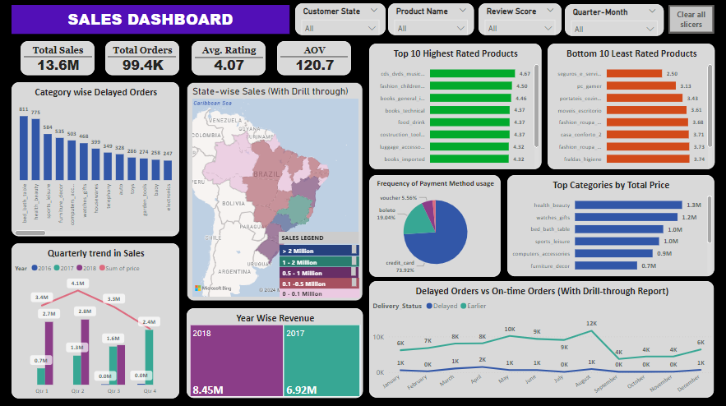The project aims to provide actionable insights to improve decision-making, enhance efficiency, and support ShopNest's continued success. The deliverables include a Power BI dashboard and a detailed report explaining the findings and visualizations.

# **1) Top Categories by Total Price**

* **Question Statement**: Identify and visually represent the top 10 product categories by total sales.
* 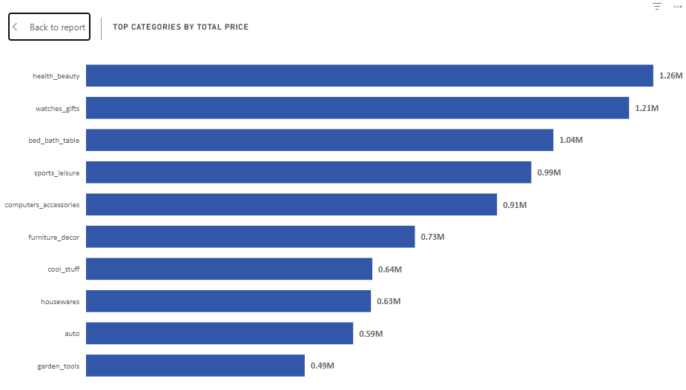**Visualization:**
* **Explanation:**

The bar chart illustrates the top 10 product categories by total sales, highlighting key revenue drivers. Health & Beauty (beleza_saude) leads with $1.26 million in sales, followed closely by Watches & Gifts (relogios_presentes) at $1.21 million, and Bed, Bath & Table (cama_mesa_banho) with $1.04 million. Additionally, Sports & Leisure (esporte_lazer) and Furniture & Décor (informatica_acessorios) also show strong performance, each exceeding $0.9 million in sales. Garden Tools (Ferramentas_jardim) and Automotive (Automotivo) follow with sales of $0.49 million and $0.59 million, respectively.

This chart underscores the importance of these top categories, providing valuable insights for strategic decision-making and resource allocation. By leveraging these insights, businesses can optimize product offerings, enhance promotional campaigns, and foster customer relationships to drive sustained growth and profitability.

# **2) Delayed Orders Analysis**

* **Question Statement**: Determine the number of delayed orders in each category. An order is considered delayed if the actual delivery date is later than the estimated delivery date.
* 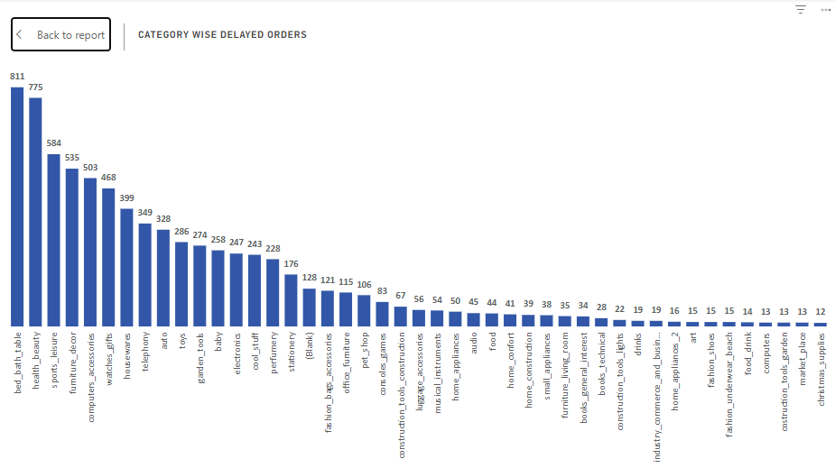**Visualization:**
* **Explanation:**

The bar chart provides a detailed breakdown of delayed orders across various product categories, offering valuable insights into sales performance and fulfillment efficiency. **"Bed, Bath & Table"** has the highest number of delayed orders, totaling 811, pointing to potential challenges in logistics and supply chain management for this category. **"Health & Beauty"** and **"Sports & Leisure"** also show significant delays, with 775 and 584 delayed orders, respectively, suggesting a need for improved coordination and process optimization.

Other categories like **"Furniture & Décor"** (535 delayed orders), **"Computers & Accessories"** (503 delayed orders), and **"Watches & Gifts"** (468 delayed orders) also face notable delays, highlighting systemic issues that require immediate attention. On the other hand, categories such as **"Diapers & Hygiene"** and **"Flowers"** show minimal delays, with just one delayed order each, indicating high efficiency in these segments.

The chart offers key insights into the factors contributing to delays, helping businesses prioritize corrective actions and allocate resources more effectively. For example, categories like **"Home Appliances"** (50 delayed orders) and **"Electronics"** (247 delayed orders) may benefit from better inventory forecasting and replenishment strategies to reduce supply chain bottlenecks and stockouts.

Ultimately, this analysis serves as a valuable tool for continuous improvement, helping businesses enhance their fulfillment processes and maintain a customer-centric approach in a competitive e-commerce environment.

# **3) Monthly Comparison of Delayed and On-Time Orders**

* **Question Statement**: Create a dynamic visual that compares the number of delayed orders to the number of orders received earlier for each month. Utilize the drill through cross-report feature to provide a detailed analysis of late and on-time deliveries.
* 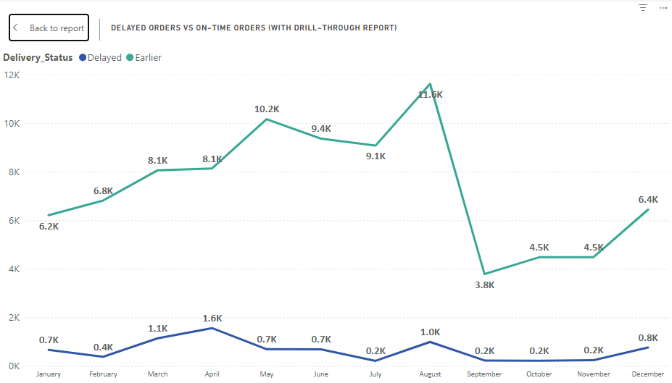**Visualization:**
* **Explanation:**

The line chart compares delayed and earlier orders across all months, offering valuable insights into order fulfillment performance throughout the year. **August** stands out with the largest gap between earlier and delayed orders, recording 11,620 earlier orders versus just 996 delayed orders, demonstrating exceptional efficiency. In contrast, **July** shows the smallest difference, with 9,078 earlier orders slightly exceeding 216 delayed orders.

Other months, such as **September** (3,790 earlier vs. 231 delayed), **October** (4,480 earlier vs. 222 delayed), and **November** (4,483 earlier vs. 245 delayed), highlight consistent strong performance in timely order fulfillment.

However, **December** and **January** see a rise in delayed orders, with 767 and 667, respectively, likely due to increased demand during the holiday season. On the other hand, **May** and **June** report fewer delays, with 691 and 696, indicating more efficient order processing during these months.

These trends provide actionable insights for the organization to address potential bottlenecks, optimize resource allocation, and develop targeted strategies to reduce delays, ultimately improving customer satisfaction and loyalty.

# **4) Payment Method Analysis**

* **Question Statement**: Analyze the most frequently used payment methods by customers using a visually appealing representation, such as a pie chart or other suitable visuals.
* 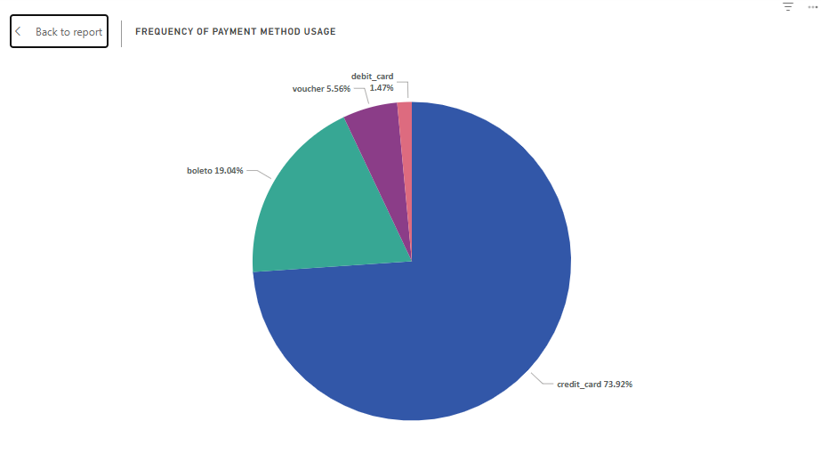**Visualization:**
* **Explanation:**

The pie chart provides an overview of customer payment preferences, revealing key insights into transaction behavior. **Credit card** is the dominant payment method, used by 76,795 customers, making up 73.9% of the total transactions. **Boleto** follows as the second most popular method, with 19,784 customers (19.0%), while **voucher** and **debit card** transactions account for smaller portions, with 5,775 (5.6%) and 1,529 (1.5%) customers, respectively.

This distribution highlights the strong preference for credit card payments, likely due to their convenience and flexibility. However, the presence of **boleto**, **voucher**, and **debit card** payments emphasizes the need for diverse payment options to cater to a broad range of customer needs and preferences.

The chart serves as a valuable tool for decision-makers, helping prioritize payment processing improvements and resource allocation to enhance transaction efficiency and meet evolving customer expectations.

# **5) Product Rating Analysis**

* **Question Statement**: Determine the top 10 highest-rated products and the bottom 10 lowest-rated products using a bar or column chart.
* 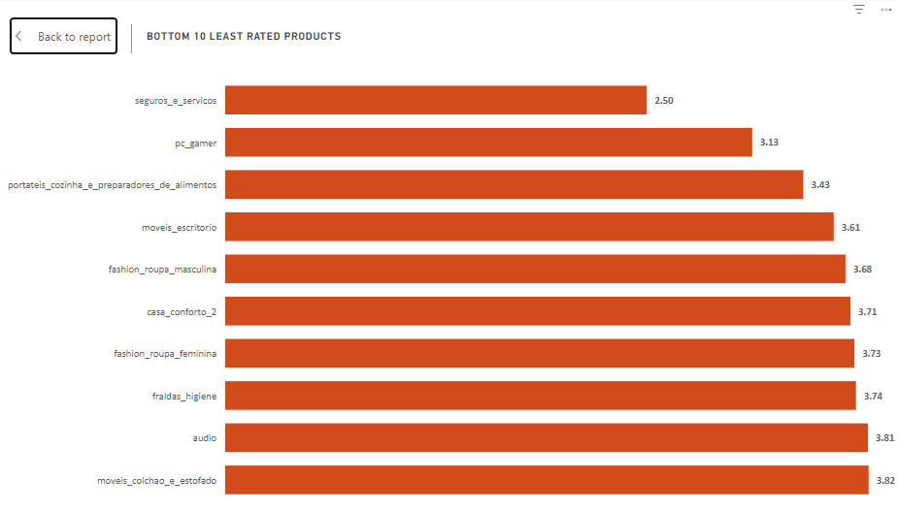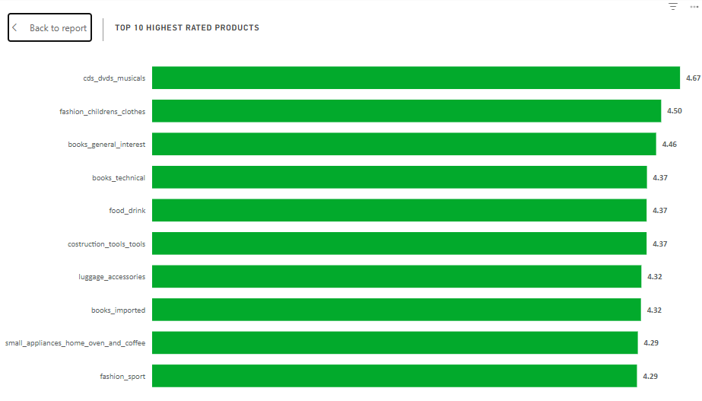**Visualization:**
* **Explanation:**

The bar chart provides an overview of the top 10 highest-rated product categories based on average customer ratings, offering insights into customer satisfaction and preferences. "CDs, DVDs, and Musicals" ranks first with an impressive average rating of 4.67, reflecting exceptional customer satisfaction. "Fashion Children's Clothes" and "Books - General Interest" follow closely with ratings of 4.50 and 4.46, respectively, indicating high appeal and quality in these categories.

Other categories such as "Books - Technical," "Food & Drink," and "Construction Tools" share a solid average rating of 4.37, signaling consistent satisfaction across a variety of products. "Small Appliances - Home Oven & Coffee" and "Fashion - Sport" also receive strong ratings of 4.29, indicating positive feedback from customers.

The chart highlights the importance of product quality and customer experience in driving satisfaction and loyalty. It also identifies product categories like "Books - Imported" and "Luggage & Accessories" as areas where premium and specialized offerings are in demand, while "Fashion Children's Clothes" and "Fashion Sport" reflect the importance of style and functionality in consumer choices.

Overall, this visualization serves as a valuable tool for businesses to assess customer sentiment, refine product offerings, and prioritize investments that will enhance satisfaction and support long-term growth.

# **6) State-wise Sales Analysis**

* **Question Statement**: Identify and visually represent states with high and low sales, providing a clear understanding of regional sales performance.
* 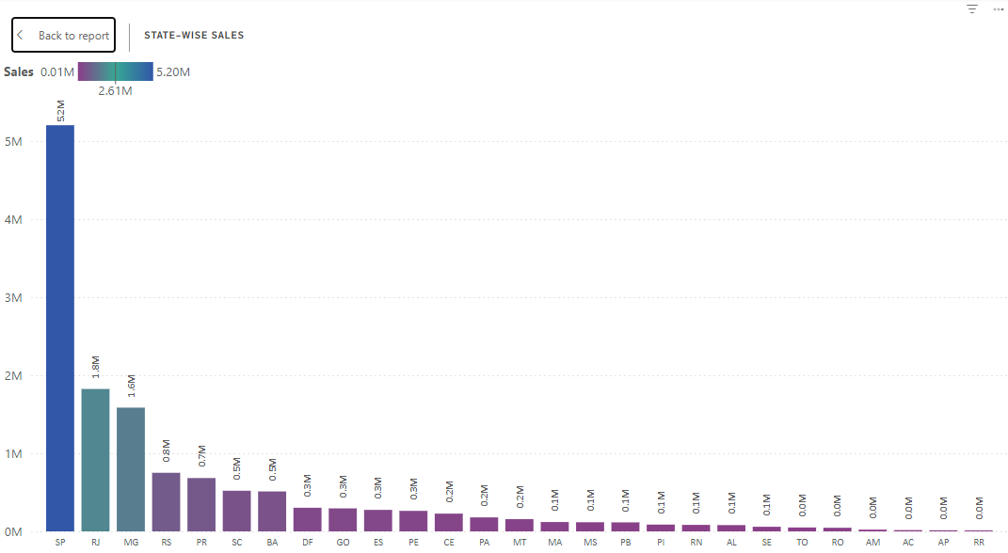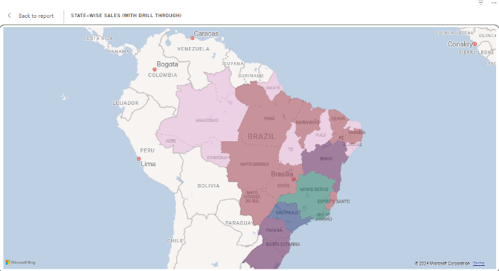**Visualization:**
* **Explanation:**

The map chart provides a detailed overview of sales performance across various states, highlighting significant regional variations. **São Paulo (SP)** leads with over $5.20 million in sales, accounting for 38.3% of total revenue. **Rio de Janeiro (RJ)** follows with $1.82 million, contributing 13.4% to the total sales.

Other states such as **Minas Gerais (MG)** and **Rio Grande do Sul (RS)** also show notable sales, generating $1.59 million (11.7%) and $0.75 million (5.5%), respectively. In contrast, **Roraima (RR)** and **Amapá (AP)** report much lower sales, with $0.007 million and $0.013 million, each contributing less than 0.1% of total revenue.

The chart's gradient representation clearly illustrates the sales distribution across states, emphasizing the dominance of São Paulo and Rio de Janeiro. At the same time, it highlights regions with lower sales as potential areas for growth.

This visualization underscores the need for strategic planning and targeted resource allocation. While major states drive significant revenue, smaller markets like Roraima and Amapá offer opportunities for expansion. The insights gained can guide decision-making, helping businesses optimize sales strategies and drive sustainable growth across diverse regions.

# **7) Seasonal Sales Patterns**

* **Question Statement**: Investigate and visualize any seasonal patterns (Quarterly) or trends in sales data over the course of the year.
* 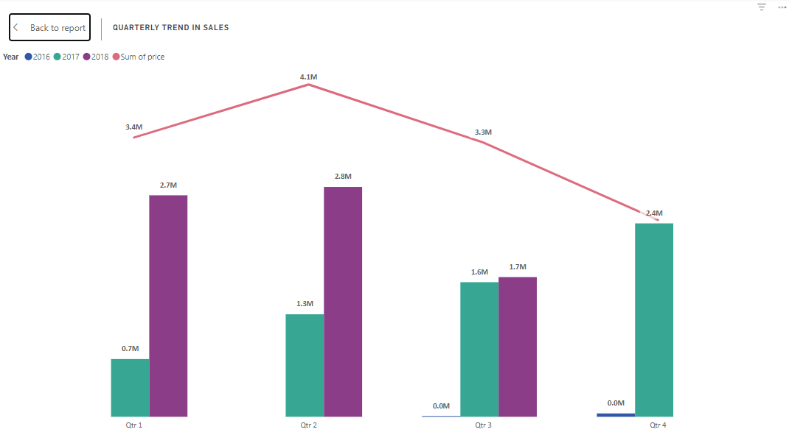**Visualization:**
* **Explanation:**

The combo chart provides an overview of quarterly sales data across multiple years, offering insights into sales trends and performance. The **bar charts** display year-over-year sales for each quarter, revealing clear growth across all quarters, with notable fluctuations. For example, **Q1** sales increased from $0.71 million in 2017 to $2.7 million in 2018, indicating strong year-over-year growth. Similarly, **Q2** sales rose from $1.25 million in 2017 to $2.81 million in 2018, reflecting continued expansion.

The **line chart** tracks total sales for each quarter, offering a comprehensive view of overall performance. The chart also highlights sales seasonality, showing that **Q2** consistently generates the highest sales, peaking at $4.1 million, followed by **Q1** ($3.4 million) and **Q3** ($3.3 million).

These seasonal trends emphasize the importance of strategic planning and resource allocation to capitalize on peak sales periods while maintaining consistent performance year-round. Overall, the combo chart offers valuable insights into sales patterns, helping businesses optimize strategies for sustained growth.

# **8)  Revenue Analysis**

* **Question Statement**: Determine the total revenue generated by ShopNest Store and analyze how it changes over time (Yearly). Represent this information through suitable visuals to highlight trends and patterns.
* 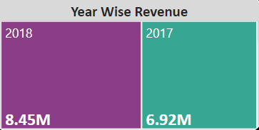**Visualization:**
* **Explanation:**

The tree chart provides a compelling visual representation of revenue trends over multiple years, offering valuable insights into the organization's financial performance and growth trajectory.

One of the most striking observations is the dramatic increase in revenue between 2016 and 2017, skyrocketing from $47,000 in 2016 to an impressive $6.92 million in 2017. This exponential growth reflects a confluence of favorable market dynamics and the successful execution of strategic business initiatives during that period.

The chart further highlights sustained momentum in revenue growth, with a remarkable surge to $8.45 million in 2018. This consistent upward trajectory underscores the organization’s ability to seize opportunities, respond effectively to evolving market conditions, and maintain robust revenue generation.

# **Conclusion**

The analysis underscores the critical importance of leveraging data-driven insights to drive strategic decisions in a competitive e-commerce landscape. By focusing on high-performing regions, addressing fulfillment inefficiencies, capitalizing on seasonal trends, and tailoring offerings to customer preferences, businesses can enhance operational efficiency, customer satisfaction, and revenue growth. The demonstrated growth trajectory and actionable intelligence provide a roadmap for sustained success, empowering organizations to adapt, innovate, and thrive in dynamic market conditions.